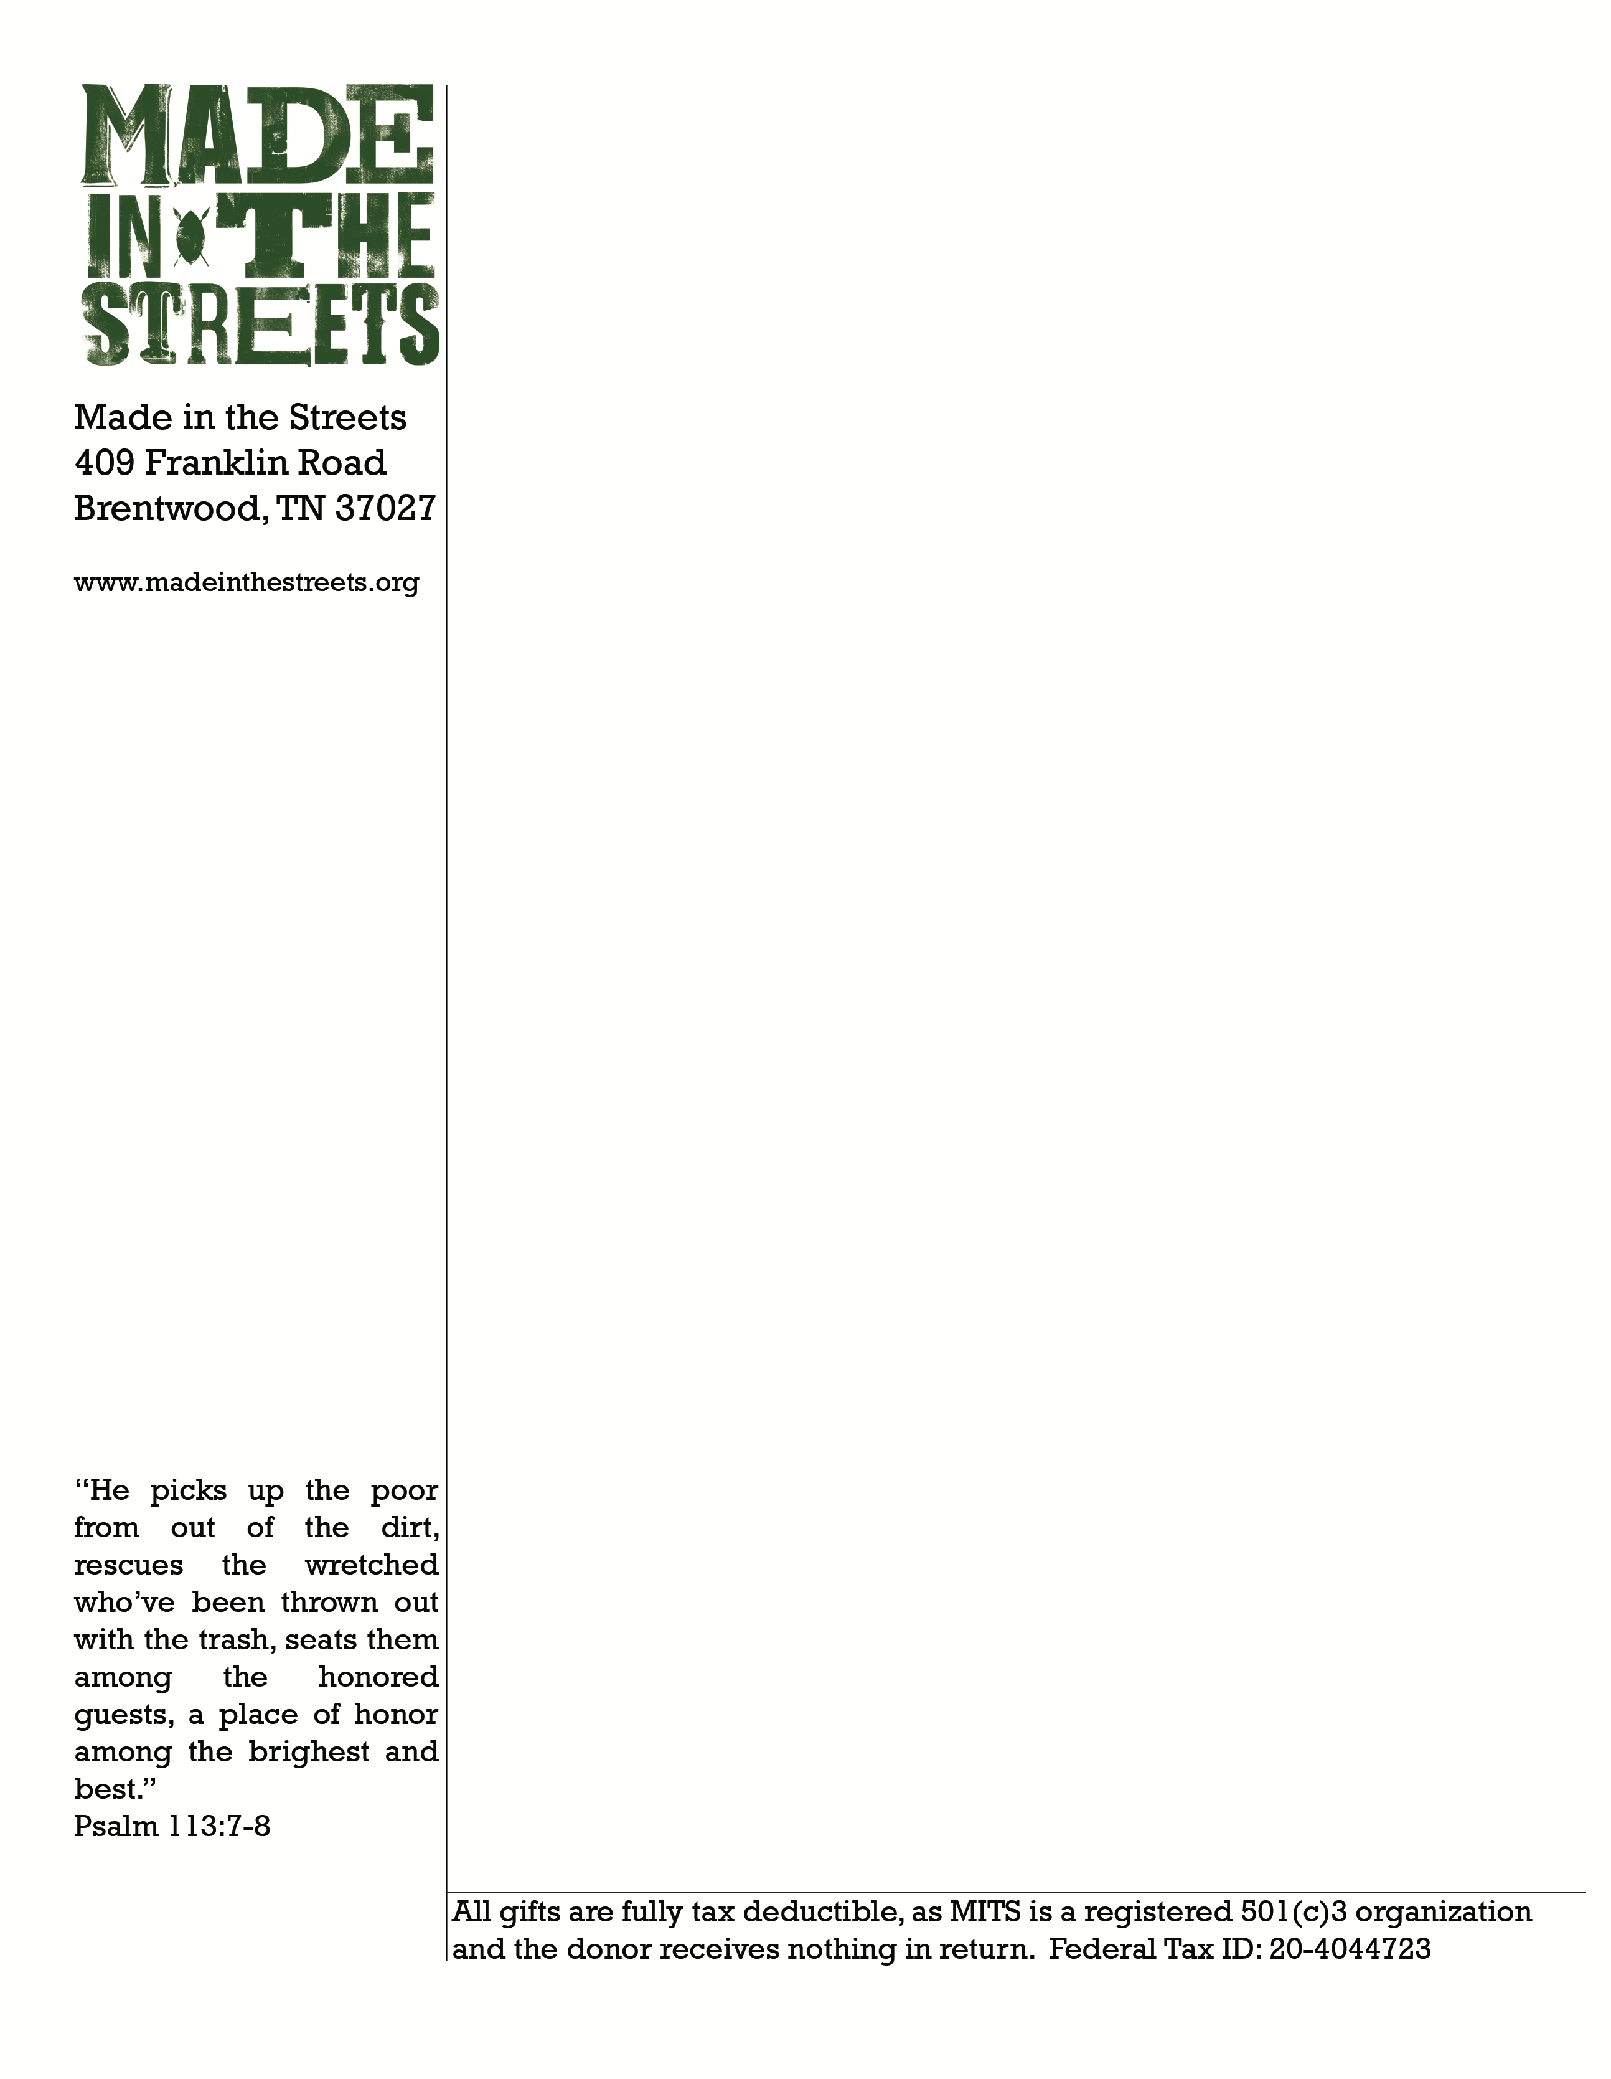
(today’s date)

To whom it may concern,

This letter is to verify that (your full name) will be serving in a missionary role with Made in the Streets (exact dates of their trip). As a volunteer, (full name) will (what they will be doing)

Sincerely,
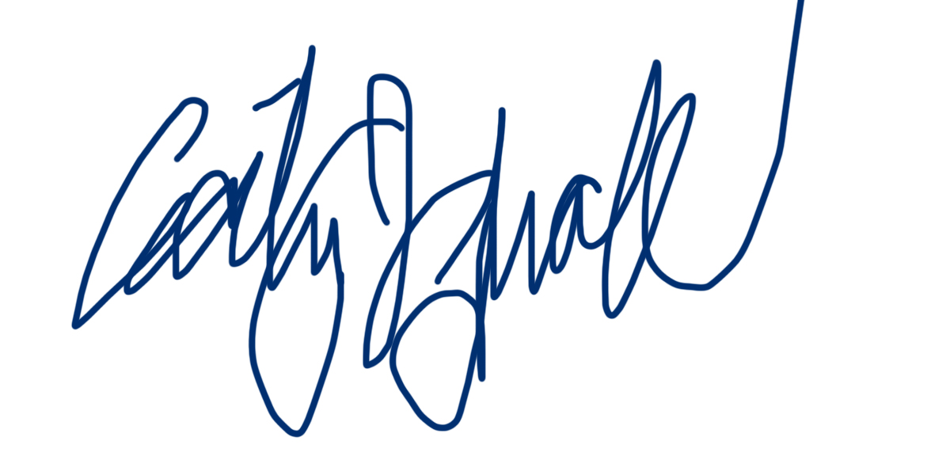
Cecily Breeding
Director of Development
on behalf of the Made in the Streets board, staff, students and volunteers

Feel free to direct any further questions to cecily@madeinthestreets.org

